# Cloud Watch

* Metrics – 14 Days (2 Weeks)
* Alarms – 14 Days (2 Weeks)
* Logs – Indefinitely

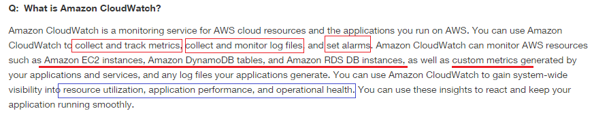

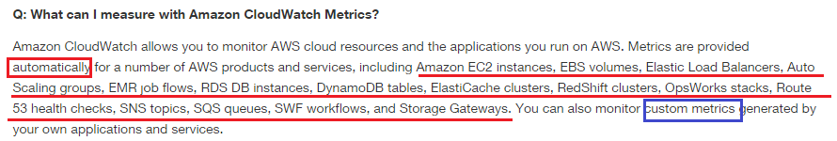



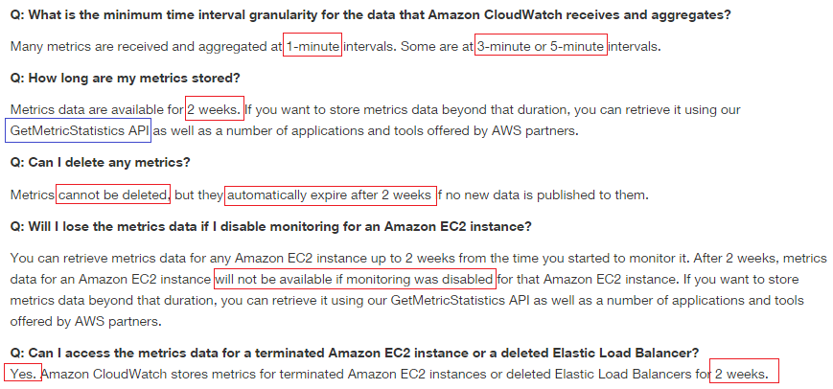

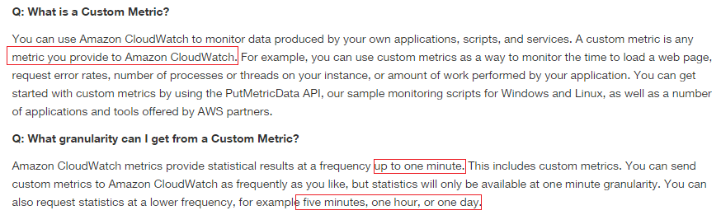

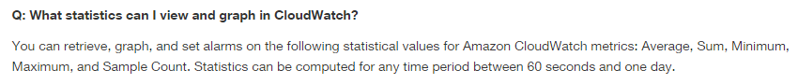

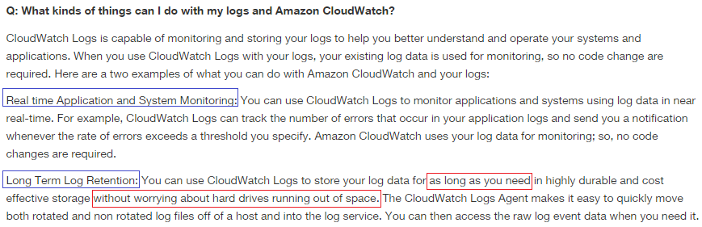

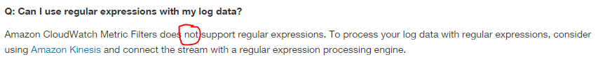

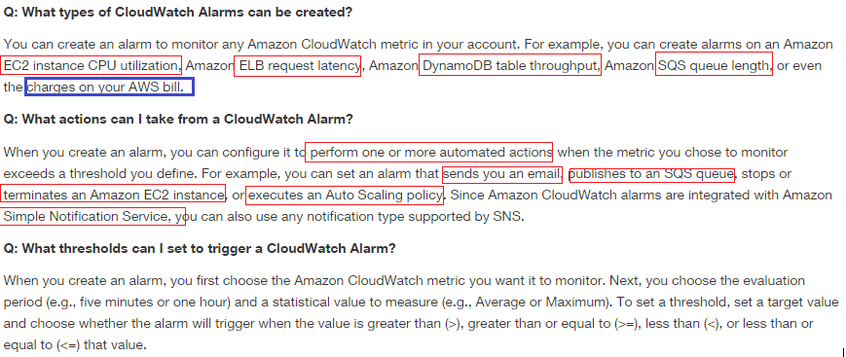

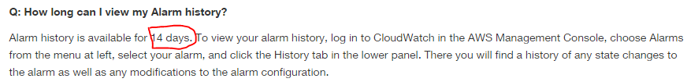

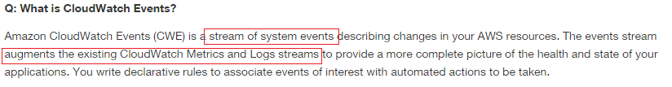

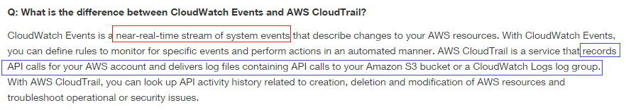

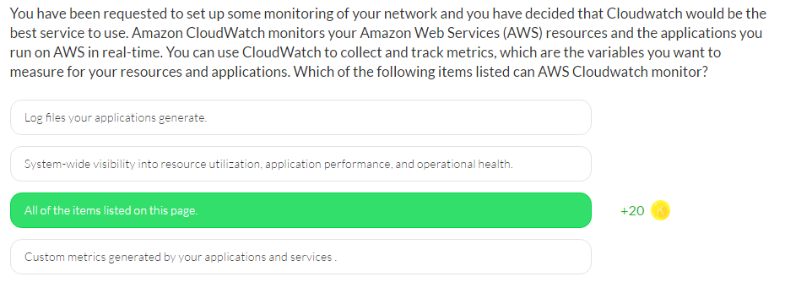

Amazon CloudWatch can monitor AWS resources such as

1. Amazon EC2 instances,
2. Amazon RDS DB instances & DynamoDB tables and
3. Custom metrics generated by your applications and services, and
4. Any log files your applications generate.

You can use Amazon CloudWatch to gain system-wide visibility into

1. Resource utilization,
2. Application performance, and
3. Operational health.
4. Memory Utilization - No

You can use these insights to react and keep your application running smoothly.

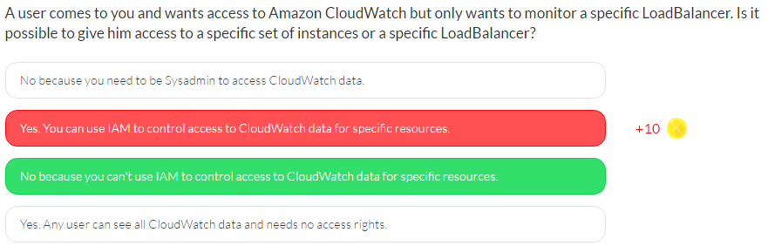

You can't use IAM to control access to CloudWatch data for specific resources.

With IAM you can specify which CloudWatch **actions** a user in your AWS Account can perform. For example, you could create an IAM policy that gives only certain users in your organization permission to use GetMetricStatistics. They could then use the action to retrieve data about your cloud resources.

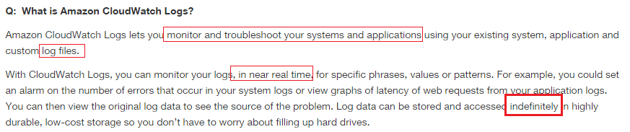

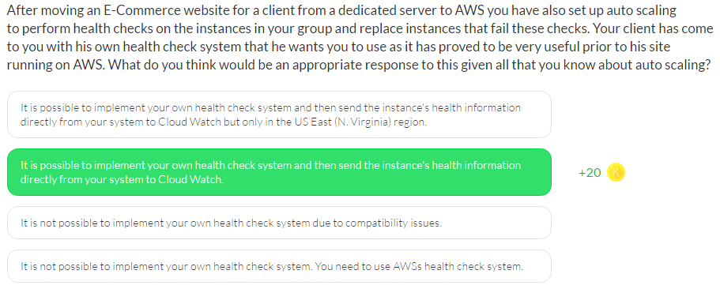

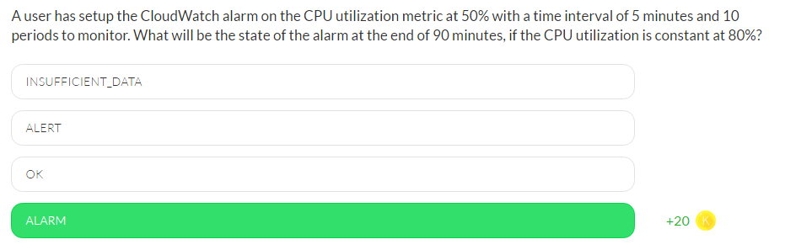

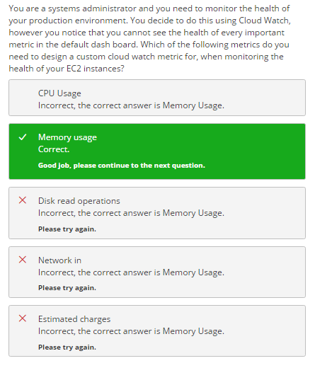

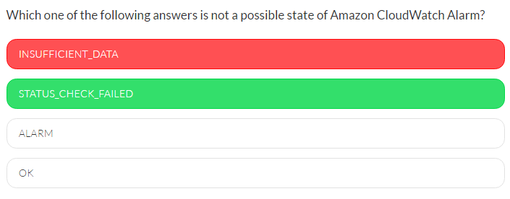

Amazon CloudWatch Alarms have three possible states:

* OK: The metric is within the defined threshold
* ALARM: The metric is outside of the defined threshold
* INSUFFICIENT_DATA: The alarm has just started, the metric is not available, or not enough data is available for the metric to determine the alarm state

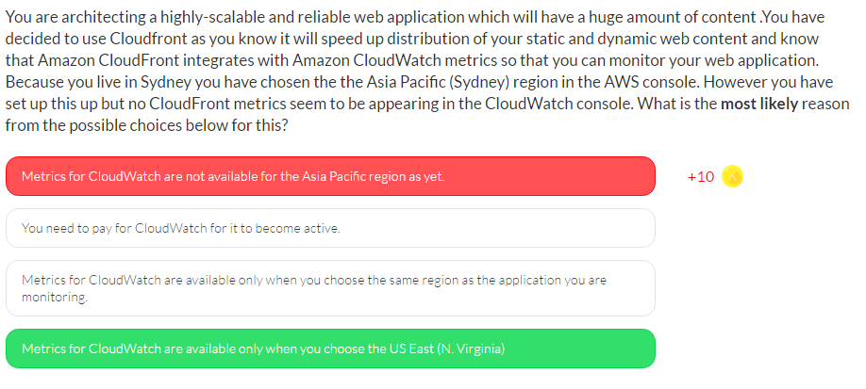

CloudFront is a global service, and metrics are available only when you choose the US East (N. Virginia) region in the AWS console. If you choose another region, no CloudFront metrics will appear in the CloudWatch console.

# Cloud Formation

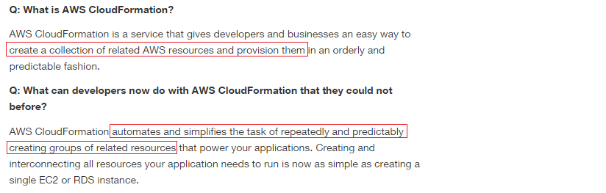

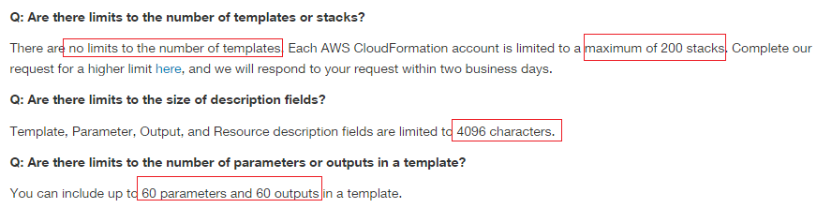

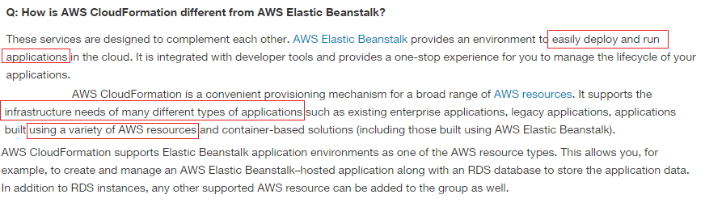

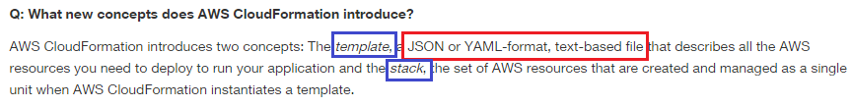

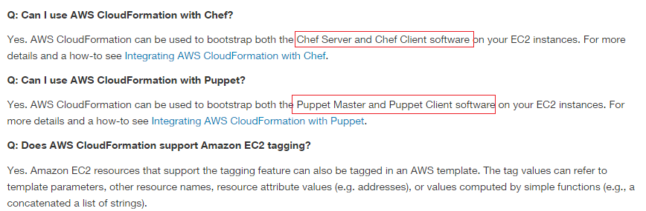

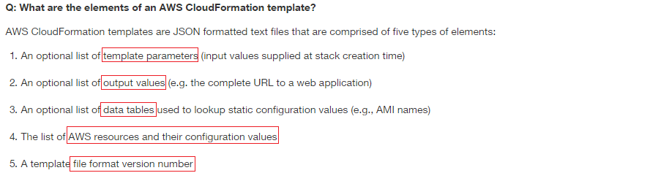



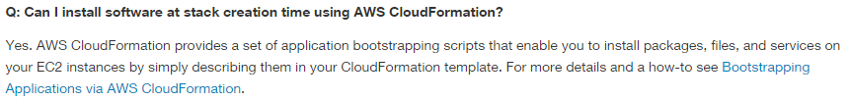

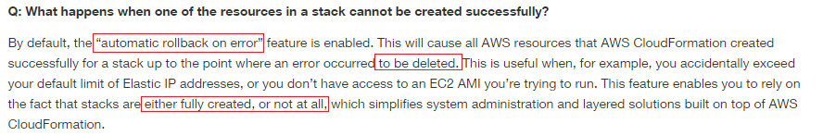

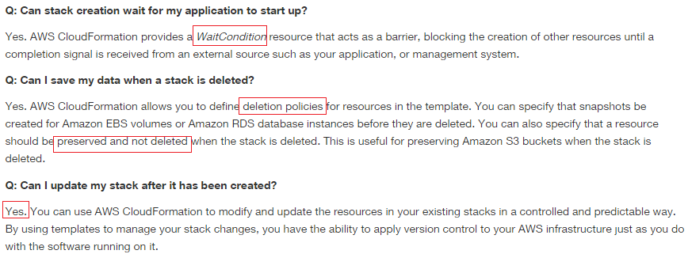

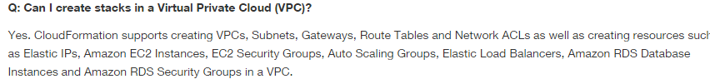

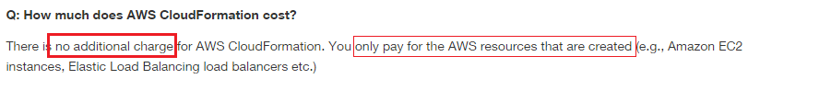

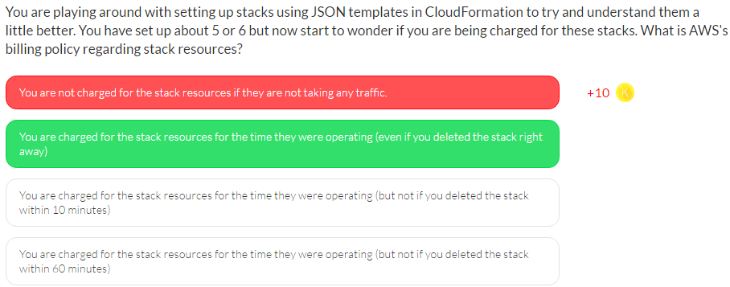

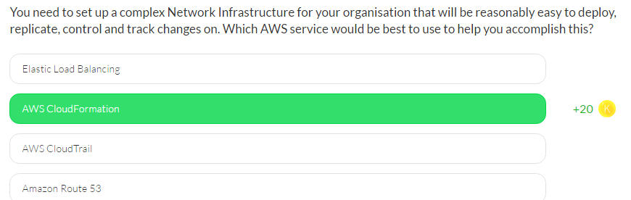

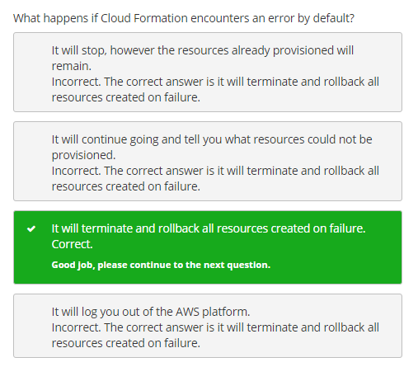

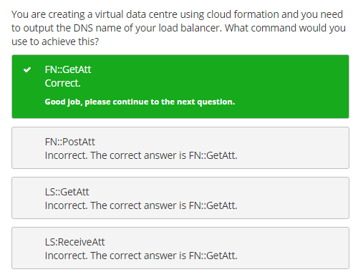

# Cloud Trail

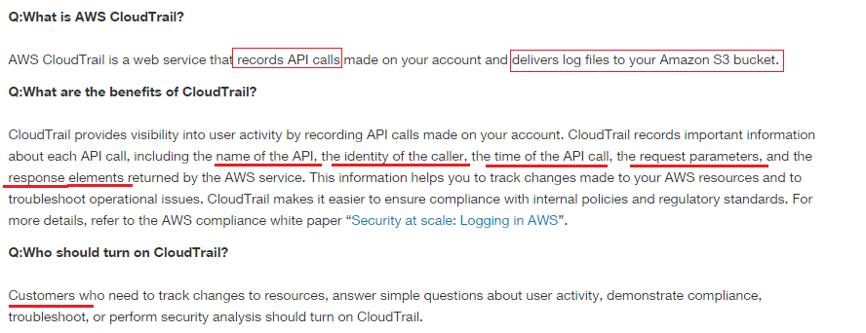

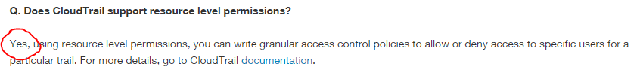

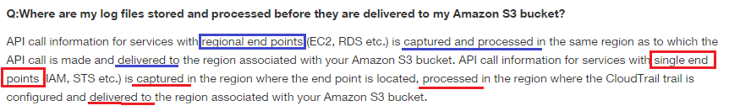

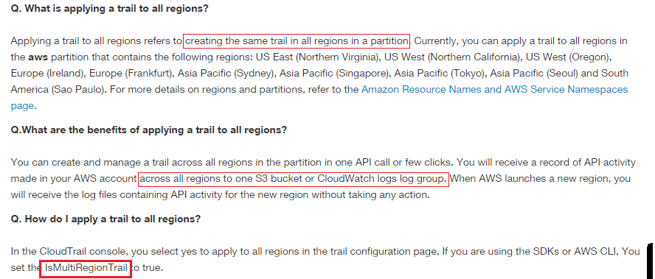

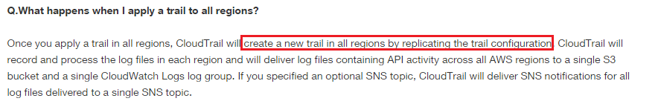

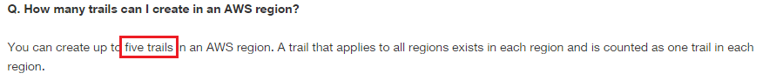

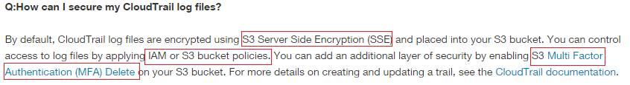

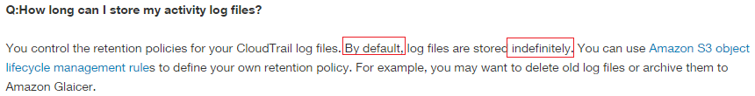

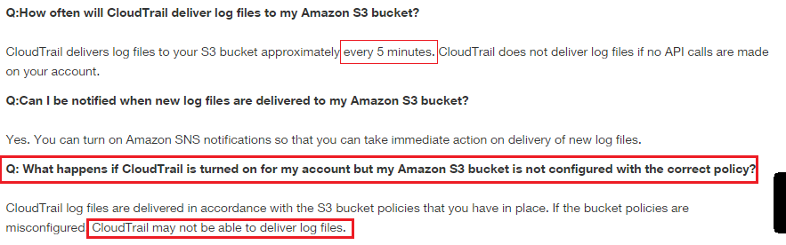

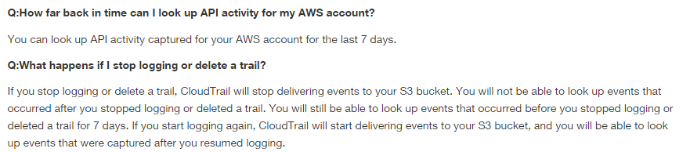

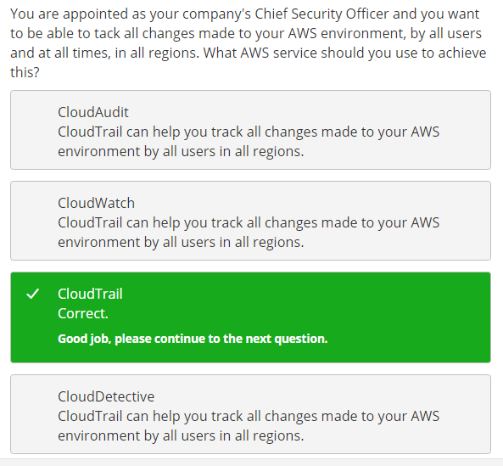

# Ops Works

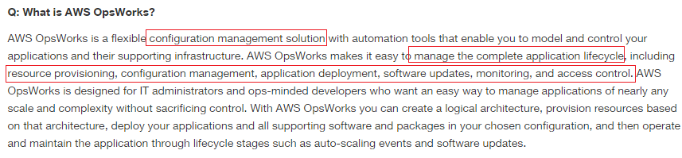

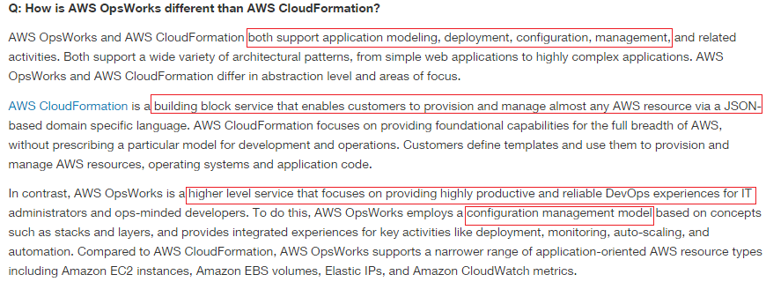

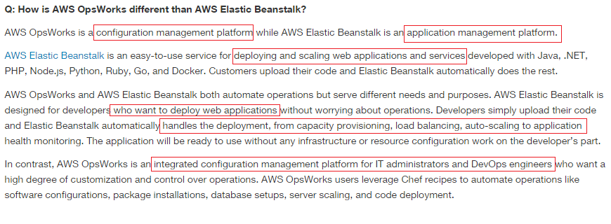

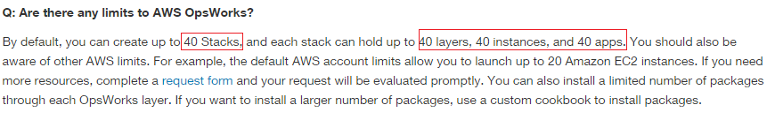

# Trusted Advisor

# Dev Ops

## Cloud Watch

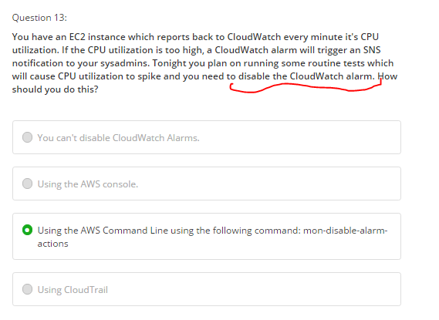

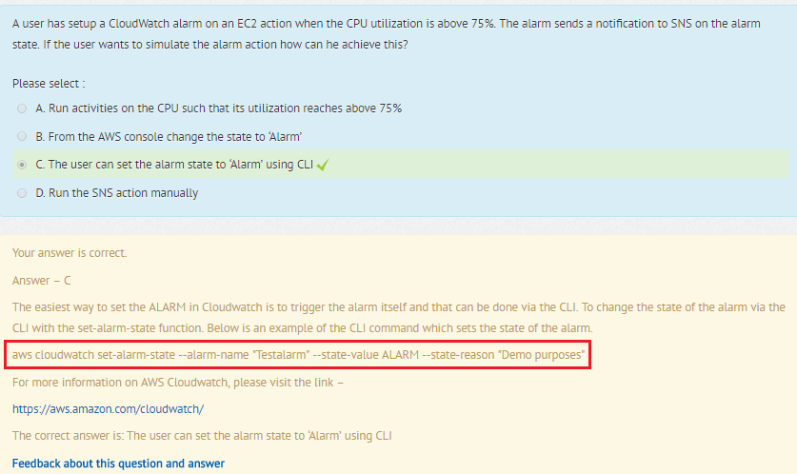

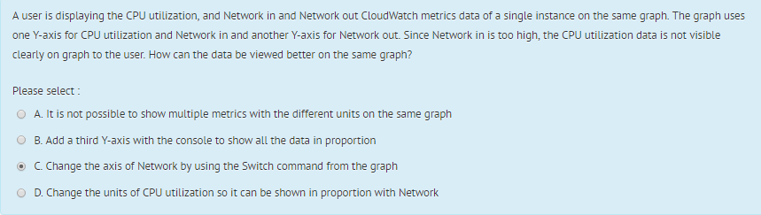

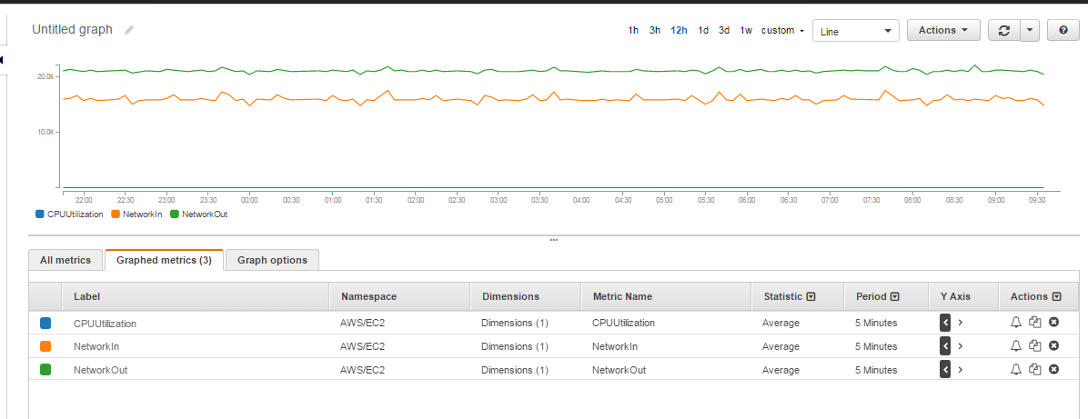

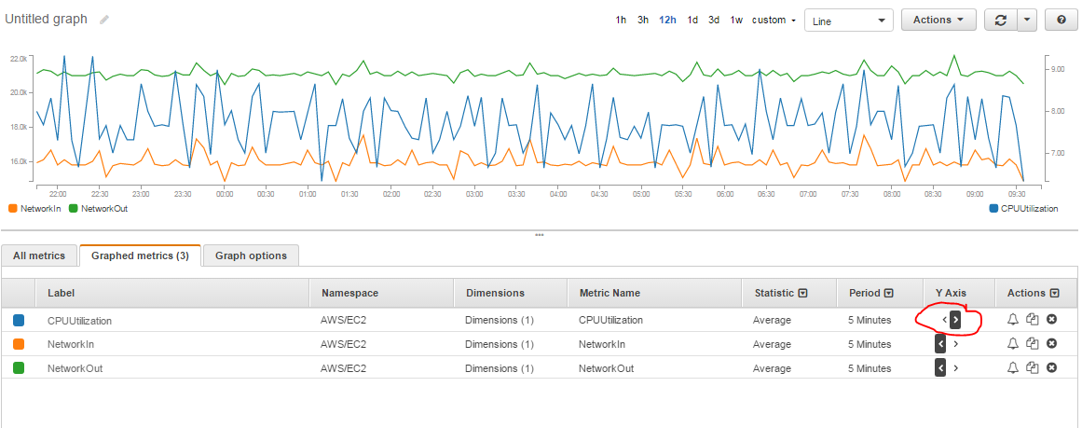

## Cloud Formation

